L021_Hillary_Dreyer Bruton_ITAI2372

Proof of Completed Lab:

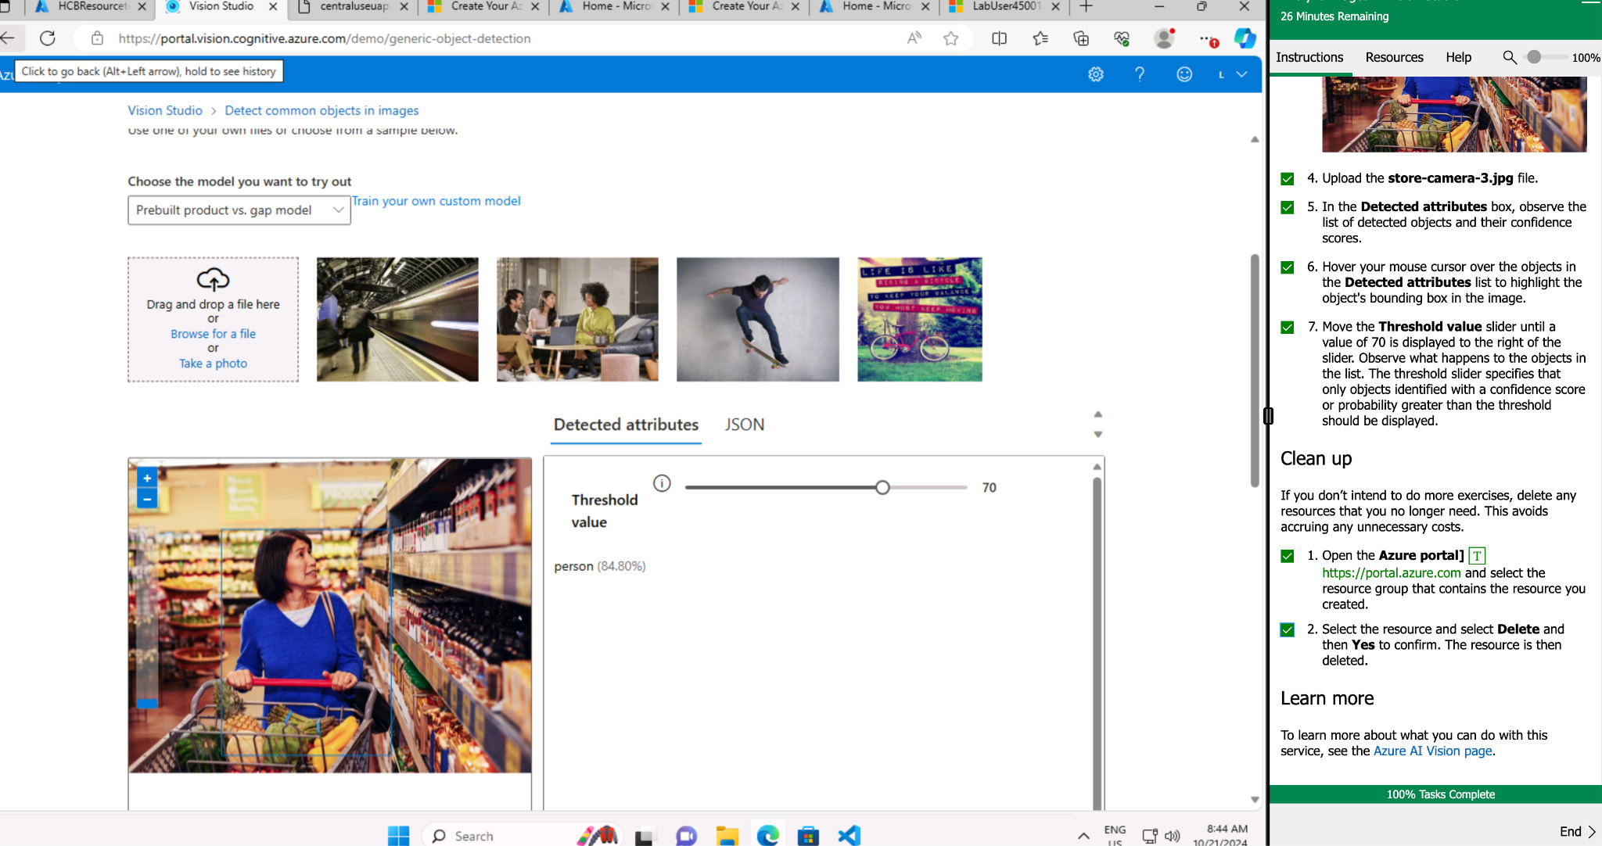

Lab 02 Reflective Journal:

What did I learn?

Lab 02, about Microsoft Vision Studio, was an introduction for me. I learned that Vision Studio offers several out-of-the-box tools for analyzing images, including tagging, captioning, categorization and detailed descriptions. These tools have sliding scales of sensitivity and confidence.

These tools could be handy in my work when providing descriptions for visually impaired site users. Additionally, it helped me become more familiar with using and assigning resource groups within the Azure environment.

What were the challenges I faced?

While the lab was informative, I had some issues that started when I tried to use the caption creation tool. The acknowledgment button required to proceed remained inactive, preventing me from accessing the tool’s functionality. After some frustration and troubleshooting, I realized that the resource needed to be created and associated with the “East US” region instead of the “Central US” I had used.

Once I made this adjustment, the acknowledgment checkbox appeared, allowing me to easily complete the lab tasks and explore the remaining highlighted features.

What insights were gleaned?

There are many use cases for the built-in features in Vision Studio. As a former web UX designer, the ability to easily understand what is in images without crafting tags and captions manually would be a huge timesaver and a better way to achieve consistent style guides with captioning. This would provide a better user experience for those on the site who are vision-challenged.